SUSPENSION SYSTEM
1.What is suspension system.?
Suspension system is a critical component of vehicle, designed to provide stability, comfort, and safety by absorbing and minimizing the impacts of road irregularities and maintaining tire contact with road. It consists of various parts and mechanism that work together to support the vehicle, ensure smooth handling, and improve overall ride quality.

- FUNCTIONS OF SUSPENSION SYSTEM.
The following are among of suspension system in a vehicle.
- Shock absorption.
One of the function of suspension system is to absorbs and dissipates the energy generated by road irregularities, such as bumps, potholes, and uneven surfaces. This reduces the impact transferred to the vehicle’s body, ensuring a smoother ride for passengers.
- Stability and control.
It helps to maintain the vehicle’s stability by preventing excessive body roll, pitch, and dive during acceleration, braking, or cornering. This ensuring the vehicle remains steady and manageable in various driving conditions.
- Maintaining tire contact.
The suspension system ensure that all tires maintain consistent contact with the road surface, even on uneven terrain. This improve traction, handling, and braking efficiency.
- Load support.
It supports the weight of the vehicle, including passengers and cargo, by evenly distributing the load across the wheels. This prevent excessive stress on individual components.
- Enhancing ride comfort.
By isolating vehicle’s occupants from road vibrations and shocks, the suspension system provides a more comfortable driving experience.
- Improved steering and handling.
Suspension system enhance the vehicle’s steering precision and responsiveness. It allows for better control during sharp turning and maneuvers, reducing the risk of understeering or oversteering.

- IDENTIFICATION OF TYPES OF SUSPENSION SYSTEM.
Types of suspension system are broadly categorized based on different factors such as their design and functionally. Let see these types
- Based on design.
- Dependent suspension system.
In this system, the movement of the one wheel is affects the other wheel on the same axle. Here a solid axle or beam connect the wheel.
Dependent system is mostly common found in heavy duties vehicle like trucks and busses.
- Independent suspension system.
This is type of suspension system that each wheel can move independently without influencing the movement of the other wheel on the same axle. This are commonly used in modern passenger cars for better comfort and handling.
- Semi-independent suspension system.
This is system that mix of dependent and independent systems. Allowing some degree of independent movement but retain a connection between the wheels
Example; Torsion beam suspension

- Based on purpose.
- Front suspension.
This is suspension that mounted at the front axle to support steering and control.
Example; MacPherson strut, double-wishbone.
- Rear suspension.
This is suspension that is installed at the rear axle to handle weight and traction.
Example; Multi-Link suspension, torsion beam.
- Based on application.
- Conventional suspension.
Is the standard system of suspension system that is used in everyday vehicles that are prioritizes comfort and stability.
- Adaptive/Active suspension.
Is the suspension system that is electronically controlled system that adjust stiffness and damping in real time.
DESCRIPTION OF NON INDEPENDENT SUSPENSION SYSTEM.
A non-independent suspension system is a type of suspension where the wheels on the same axle are connected by a rigid beam or axle. In this system, the movement of one wheel directly affects the other wheel on the same axle. This is in contrast to independent suspension system, where each wheel moves independently.
Characteristics of non-independent suspension.
- Rigid connection: This means that both wheels are connected by a solid axle or beam.
- Simpler design: Non-independent suspension systems are mechanically simpler and more robust.
- Cost-effective: This means it has less expensive to manufacture and maintain compared to independent systems.
Advantages of non-independent suspension system.
- Suitable for heavy-duty applications due to its robust design.
- Non independent system having load-bearing capacity
- They have simple design so make easier and cheaper to maintain.
- They also have a good stability on the straight roads.
Disadvantages of non-independent suspension system.
- Poor ride quality as road shocks are transmitted across the axle.
- They have limited handling, due to less responsive to steering and road conditions.
- They are unstable on uneven surfaces
Applications of non-independent suspension system.
This system is mostly used in;
- Heavy-duty vehicle (trucks, buses).
- Low-cost and older passenger vehicles.
- Off-road vehicles requiring high durability.

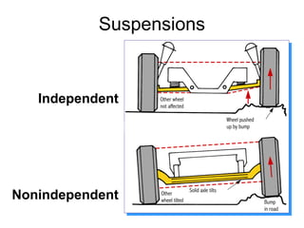
Figure 1:Diagram of Independent suspension system and Non-Independent suspension system.

DESCRIPTION OF INDEPENDENT SUSPENSION SYSTEM.
An independent suspension system is a type of suspension where each wheel on the same axle operates independently of the other. This means that the movement or disturbance of one wheel does not directly affect the other wheel on the same axle. It is used in modern vehicle to improve comfort, handling and stability.
Characteristics of independent suspension system.
- Each wheel moves independently, ensuring better adaptability to road irregularities.
- Independent suspension system enhanced ride quality.
- It is complex in design.
Advantages of independent suspension system.
- An independent suspension system has a better ride comfort, due to absorbs shocks more effectively.
- It enhances cornering stability and steering precision.
- It maintains consistent contact between the tires and road, thus improving traction.
- It reduced unsprung weight.
- It is flexible for modern designs.
Disadvantages of independent suspension system.
- It has more intricate design leads to higher manufacturing and maintenance cost.
- Less robust compared to non-independent systems in heavy-duty applications.
- Greater number of parts makes repairs more complicated.
Application of independent suspension system.
Independent system mostly used in;
- Passenger cars.
- Sports cars and high-performance vehicle.
- Luxury-vehicle.
- Light trucks and SUVs for improved comfort and handling

IDENTIFYING THE TYPES OF SPRINGS IN SUSPENSION SYSTEM.
Springs are a vital component of a suspension system, as they absorb and store energy from road impacts to ensure a smooth ride. The types of springs used in suspension system include;
- COIL SPRING.
Is a helical-shaped metal springs made of steel or other alloys. Which it’s function is to compress and expand to absorb shocks from the road.
Widely used in cars, light trucks, and SUVs, often paired with MacPherson struts or double wishbone suspension.
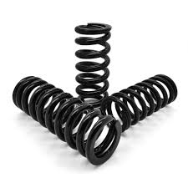
Figure 2: Coil springs
- LEAF SPRINGS.
Is a stack of curved, flat metal strips (leaves) bound together, whose it’s function is to distributes loads evenly and absorbs shocks, and is commonly used in heavy-duty vehicle like trucks, buses, and trailers.
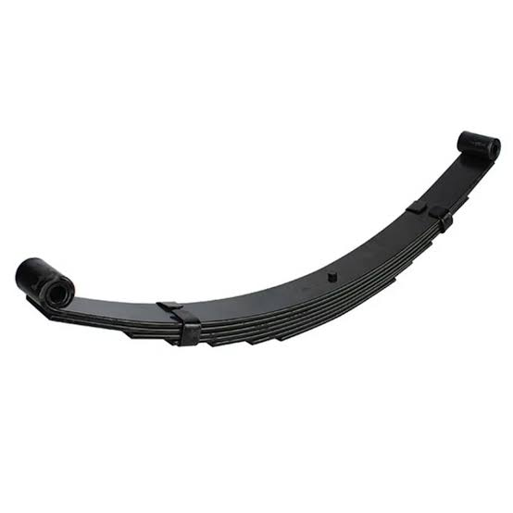
Figure 3: Leaf spring
- AIR SPRINGS.
This is type of spring that having a rubber or synthetic air-filled bags that replace the traditional spring.
It uses a compressed air to adjust suspension height and stiffness.
It used on Luxury vehicles, buses, and trucks requiring adjustable suspension.
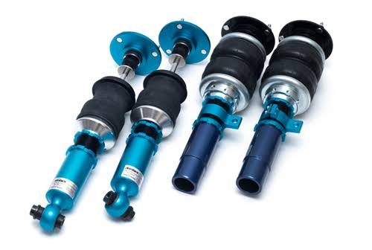
Figure 4: Air springs
- TORSION SPRING (TORSION BARS).
Is the steel bar that twists along it’s axis to absorb energy, and providing suspension by twisting under load.
This springs founds in off-road vehicle, older cars, and light trucks.
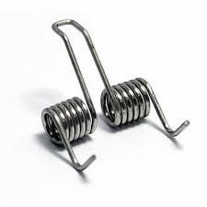
Figure 5: Torsion spring
- RUBBER SPRINGS.
These are flexible rubber that have being made to act as a spring, which are used to absorbs energy and reduces vibrations.
This are found in small trailer or light -duty applications

- HYDRAULIC SPRING.
This is type of spring that uses hydraulic fluid to dampen and absorb shocks. This combine the all function of springs and dampers.
It found in advanced suspension systems for luxury or off-road vehicles.
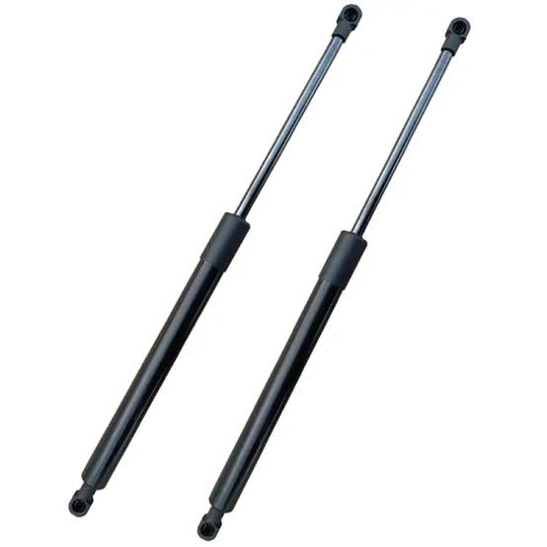
Figure 6: Hydraulic springs
PNEUMATIC SUSPENSION SYSTEM.
A pneumatic suspension system, also known as an air suspension system, is a type of vehicle suspension that uses compressed air instead of conventional spring (like coil or leaf spring). The air is stored in flexible rubber or synthetic air bags (air spring), which support the weight of the vehicle and absorb shocks from road irregularities.
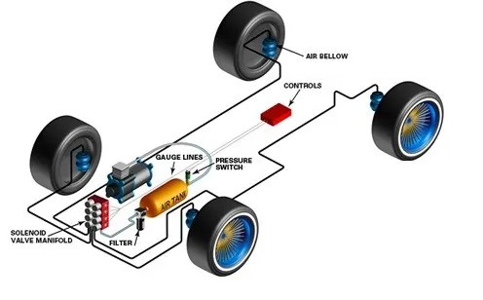
Figure 7: Diagram of Pneumatic suspension system
COMPONENTS OF PNEUMATIC SUSPENSION SYSTEM.
- Air springs;
Rubber or synthetic air-filled bags that act as the primary suspension medium.
- Air compressor;
Stores compressed air for consistent supply and quick adjustments.
- Height sensors;
This monitors the rides height and sends signals to adjust the suspension when needed.
- Control module;
An electronic unit that control air distribution and adjusts ride height and stiffness.
- Valves and pipes;
Direct airflow between the compressor, reservoir, and air springs.
Advantages of pneumatic suspension system.
- It allows the driver to raises or lower the vehicle based on the road condition or load.
- It provides superior ride quality and absorbing shocks effectively.
- Automatically adjusts to maintain an even ride height regardless of the load load distribution.
- Offers better stability and control during cornering and braking.
- It is suitable for both heavy-duty vehicles and luxury cars.
Disadvantages of pneumatic suspension system.
- More components and electronics makes it a complex system.
- Expensive to manufacture, install and repair compared to conventional suspension system.
- Air compressors require additional power, affecting overall efficiency.

IDENTIFY TYPES OF SHOCK ABSORBER.
Shock absorber are a crucial part of a vehicle’s suspension system, designed to dampen vibrations and control the rebound of spring after they absorb road shocks. Various type of shock absorbers are used based on vehicle design, performance requirements, and operating conditions
Here are the main types;
- Twin-tube shock absorber.
This is the type of shock absorber that consist of two cylinders-an inner working tube and an outer reservoir tube. The piston moves within the working tube, displacing hydraulic fluid into the reservoir tube to absorb shocks.
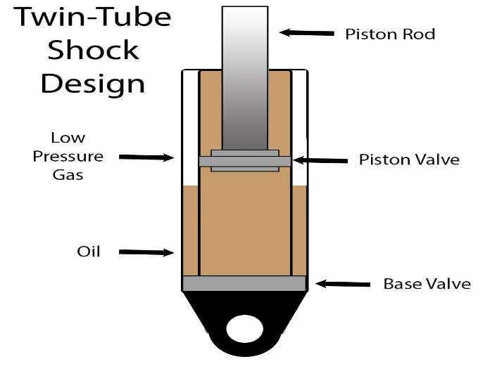
Figure 8: Twin-tube shock absorber
It has two types which are; Twin-tube gas charged and Twin-tube hydraulic (Oil-filled)
- Mono-tube shock absorber.
Is the shock absorber that contain a single tube divided into two chambers-one for hydraulic fluid and for pressurized gas (often nitrogen).The piston moves through the hydraulic fluid, with gas pressure aiding in damping.
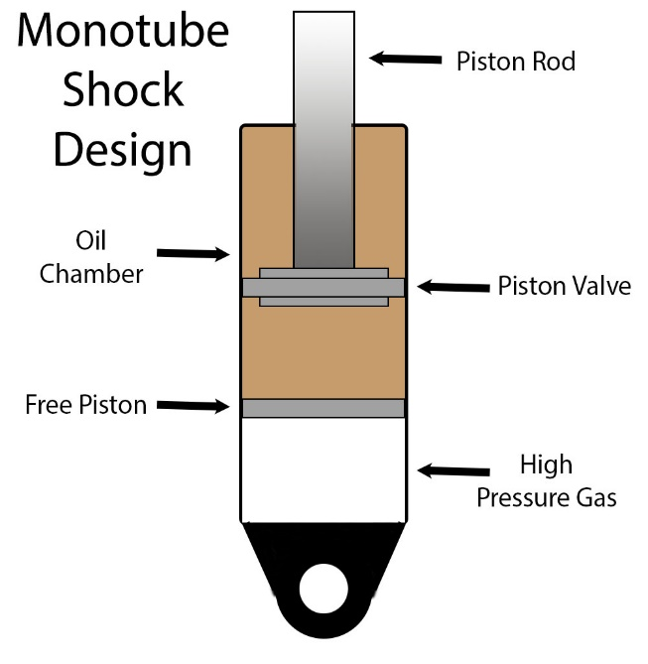
Figure 9: Mono-tube shock absorber

- Gas-filled shock absorber.
Is the type of shock absorber that is either mono-tube or twin-tube that is design with pressurized gas to reduce oil foaming. It improves response time and provides better damping characteristics.
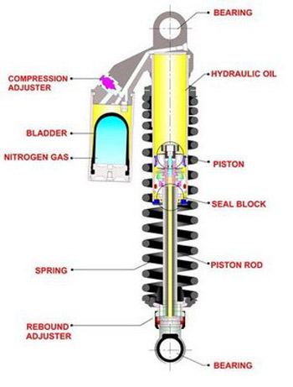
Figure 10: Gas-filled shock absorber.

- Adjustable shock absorber.
Is the type of shock absorber that allows manual or electronic adjustment of damping force to suit driving conditions. It’s enables customization for comfort or performance.
`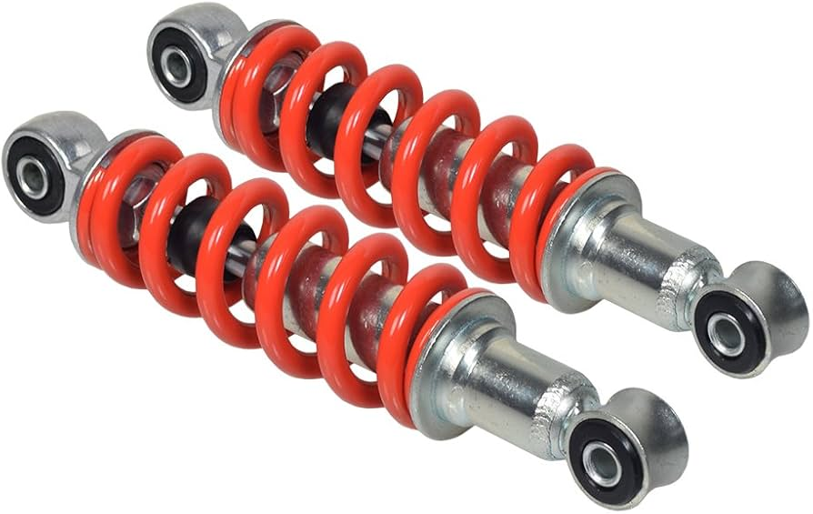
Figure 11: Adjustable shock absorber
- Air shock absorber.
This is type of shock absorber that uses air pressure instead of hydraulic fluid to provide damping and adjust ride height. Commonly paired with air suspension systems in luxury or heavy-duty vehicles.
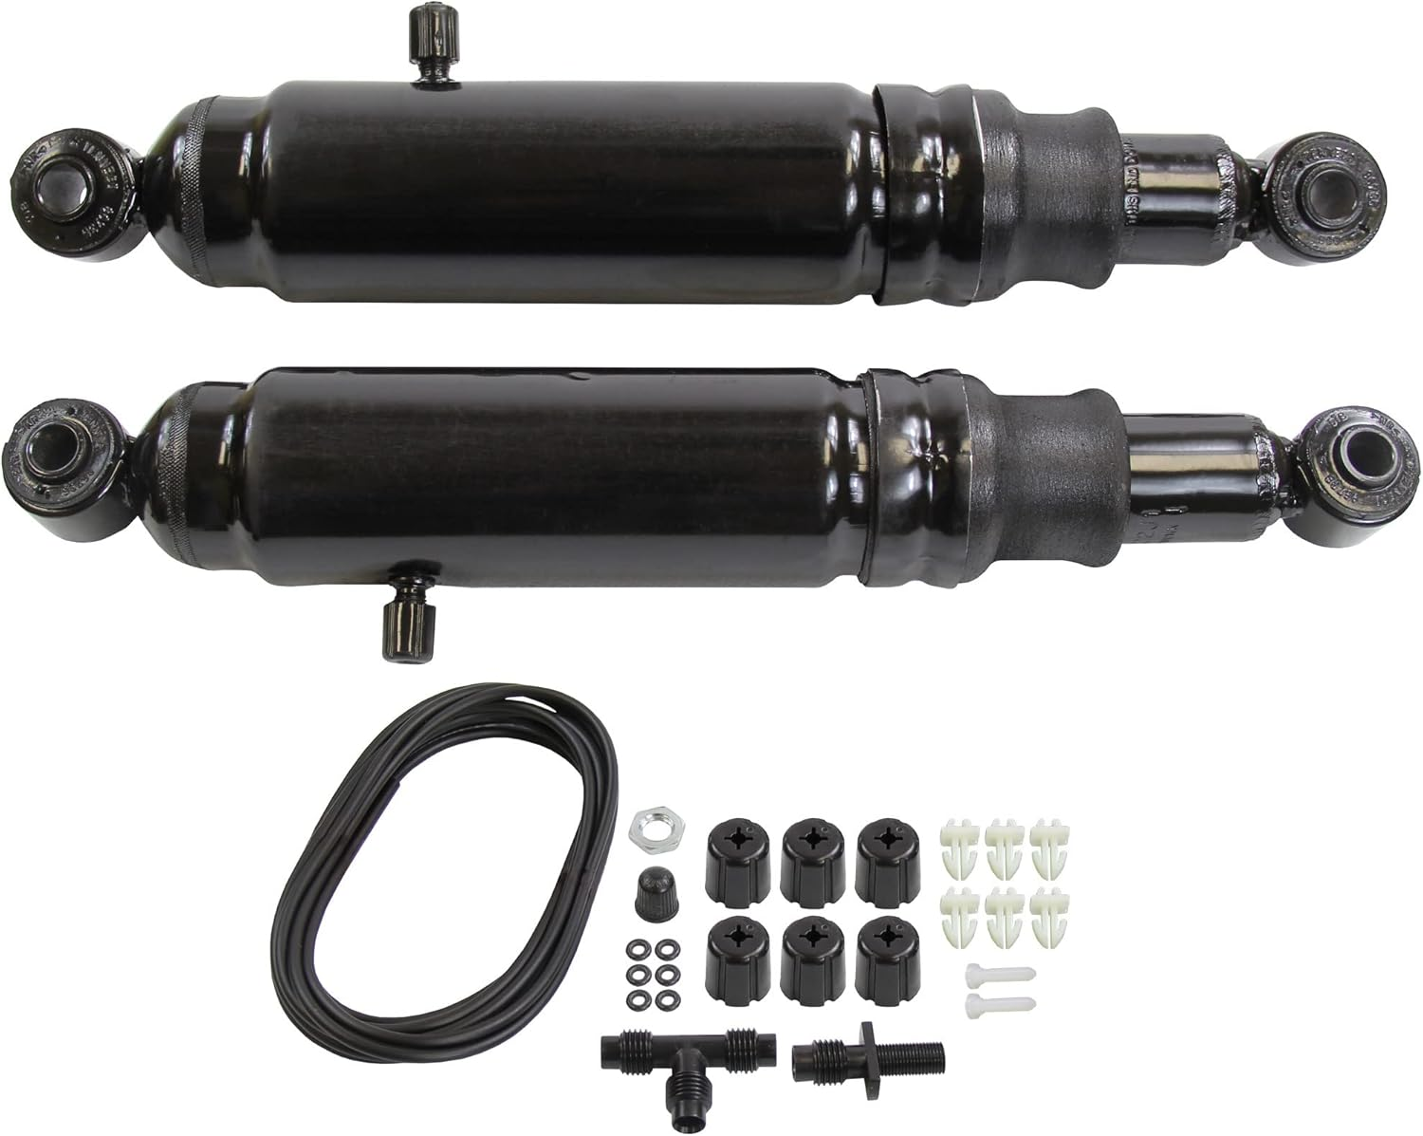
Figure 12: Air shock absorber
- Magnetic ride shock absorber (Magnetorheological shock).
This type uses magnetorheological fluid (sensitive to magnetic field) for adjustable damping. It controlled electronically for real-time adjustment to road conditions.
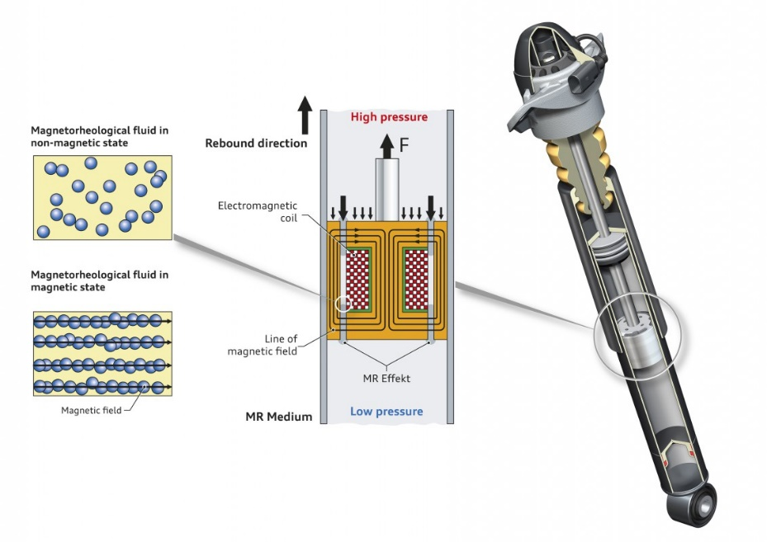
Figure 13: Magnetic ride shock absorber

FAULTS AND REMEDIES IN SUSPENSION SYSTEM.
Faults in vehicle’s suspension system can lead to decrease comfort, handling issues and safety concerns. Identifying these faults and implementing appropriate remedies is essential to maintain optimal vehicle performance.

Common suspension system faults and their remedies.
- Worn-out shock absorbers.
Symptoms;
- Excessive bouncing after hitting a bump.
- Reduced vehicle stability and handling.
- Uneven tire wear.
Cause.
- Prolonged use or exposure to rough terrain.
- Leakage of hydraulic fluid in the shock absorbers.
Remedies.
- Replace damaged or worn-out shock absorbers.
- Inspect and replace related components, such as mounts or bushings.
- Broken or worn spring.
Symptoms;
- Sagging of the vehicle on one side.
- Noise during driving, especially over bump.
- Reduce ground clearance.
Causes;
- Overloading or excessive stress on the spring.
- Corrosion or material fatigue.
Remedies;
- Replace broken or worn-out springs.
- Avoid overloading the vehicle to prevent future issues.
- Misaligned suspension components;
Symptoms.
- Steering pulls to one side.
- Uneven tire wear.
- Poor handling or instability.
Causes;
- Hard impact, such as hitting potholes or curbs.
- Improper installation of suspension components.
Remedies;
- Perform a professionally wheel alignment.
- Inspect and adjust suspension components to their correct position
.

- Faulty or worn bushings.
Symptoms.
- Knocking or creaking noises during driving.
- Excessive vibrations in the cabin.
- Reduced handling precision.
Causes;
- Wear and tear due to age or lack of lubrication.
- Exposure to extreme temperature or contaminants.
Remedies;
- Replace worn or damaged bushings.
- Ensure proper lubrication during installation.
- Damaged ball joint.
Symptoms;
- Steering feels loose or imprecise.
- Clunking noise when turning or driving over bumps.
- Uneven tire wear.
Causes;
- Wear due to age or poor maintenance.
- Corrosion or contamination of the joint
Remedies;
- Replace damaged ball joints immediately to ensure safety.
- Regularly inspect and maintain ball joints.
- Air suspension failure.
Symptoms;
- Vehicle sits lower than normal or unevenly.
- Ride height adjustment malfunctions.
- Warning light on the dashboard.
Causes;
- Air leaks in the air springs or lines.
- Faulty air compressor or sensors.
Remedies;
- Repair or replace damaged air spring or hoses.
- Test and repair the air compressor and associated electronics.

